**INTERNATIONAL MARKETING EVALUATION**

**TABLE OF CONTENTS**

**CONTENT PAGE**

**Introduction 4**

1.1 Background of the Company 4-5

**External Environmental Factors Impact 7-8**

**Consumer Behaviour Analysis: Nigeria and Malaysia 9**

**Competitor Analysis: Nigeria and Malaysia 11-12**

**Entry Strategy Evaluation**

5.1 Nestlé's Entry Strategy in Nigeria 13

5.2 Nestlé's Entry Strategy in the Malaysia 14

**Segmentation, Targeting, and Positioning Analysis 16**

6.1 Nestlé's Segmentation, Targeting, and Positioning in Nigeria 16

6.2 Nestlé's Segmentation, Targeting, and Positioning in the Malaysia 17

6.3 Comparative Analysis 17

**Marketing Strategies (4 P’s) Evaluation 19**

7.1 Product Strategy 19

7.2 Price Strategy 20

7.3 Place (Distribution) Strategy 20

7.4 Promotion (Advertisement) Strategy 21

**Conclusion 21-22**

**References 23-25**

**1.0 INTRODUCTION**

**1.1 Background of the Company**

Nestlé, a Swiss multinational food and beverage corporation, is a prominent global leader in the industry (Huang, 2023). Established in 1866, the corporation has developed into a dominant force, overseeing a wide range of popular brands (Alexander *et al*., 2011). Nestlé's dedication to the purpose of "Good Food, Good Life" highlights its commitment to providing high-quality, nourishing goods that improve the lives of people worldwide (Sánchez *et al*., 2016). Nestlé operates in more than 180 countries and has a workforce of over 270,000 individuals (Demir & Istanbullu Dincer, 2020). The company offers a wide range of products, including coffee, chocolate, infant nutrition, and pet care (Marin & Verdier, 2007).

**Figure 1.1:** Financial Figure of 10 selected FMCG companies worldwide 2021

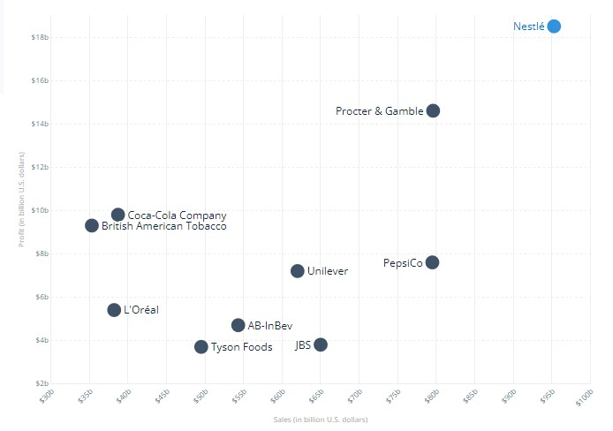

The company's financial success, as reflected in its 2023 half-year results in Nestlé, 2023 includes significant organic growth of 8.7%, pushed by strategic pricing and true internal growth (Nestle India Ltd Share Price Today - Nestle India Ltd Share Price LIVE on NSE/BSE, n.d.). Despite facing challenges like as foreign exchange impacts and minor net acquisitions, Nestlé's financial outlook remains solid, with an enhanced full-year projection and a commitment to continued portfolio management. (Topic: Nestlé, 2024)

**Figure 1.2:** Organizational Chart of the Company

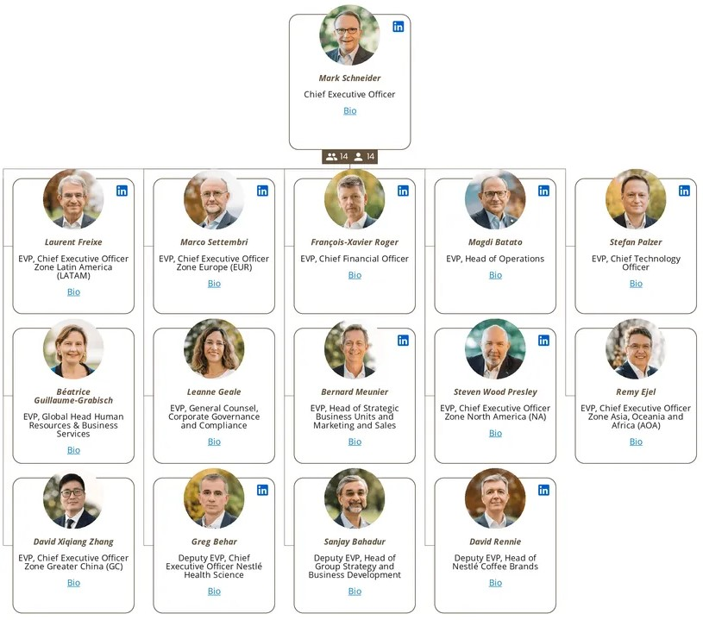

**Source:** (*Our leadership team*, n.d.)

Nestlé's strategic innovation connects with sustainable and responsible business practices. The company harnesses its global scale to address societal concerns, actively engaged in producing shared benefit for both shareholders and communities globally (Ching, 2022). Nestlé's commitment to corporate governance stresses openness, accountability, and ethical conduct, assuring good decision-making and risk management throughout its broad global businesses (Post, 1985).

In a competitive market distinguished by tough adversaries, Nestlé navigates the challenging balance between regional autonomy and global coherence through its organizational structure (Bhasin, 2023). The company's emphasis on adaptation and innovation is important for flourishing in a market where consumer preferences regularly alter (Cuofano, 2023). Understanding and strategically placing itself against competitors such as Unilever, Coca-Cola, PepsiCo, and others, Nestlé remains a resilient force in the dynamic food and beverage sector (Nestle SA Peers & Key Competitors - GlobalData, n.d.).

**2.0 EXTERNAL ENVIRONMENTAL FACTORS IMPACT**

|  |  |  |
| --- | --- | --- |
| **Factors** | **Nigeria** | **Malaysia** |
| **Political Factors** | Government initiatives supporting local sourcing. | Positive government stance on foreign investment. |
|  | Policy changes and bureaucracy challenges. | Stable political environment. |
|  | Currency fluctuations affecting import costs. | Adherence to food and nutrition policies. |
|  | Market potential with a growing middle class. | Alignment with Vision 2030 for inclusive growth. |
|  | Operational challenges due to infrastructure weaknesses. | Potential collaboration on public health initiatives. |
| **Social Factors** | Emphasis on family and community in culture. | Cultural richness influencing culinary traditions. |
|  | Health awareness and eating habits evolving. | Strong emphasis on family and community. |
|  | Localization opportunities based on cultural diversity. | Growing environmental awareness and sustainability. |
|  | Consumer trends and preferences among the youthful population. | Religious sensitivities and halal certification. |
|  | Opportunities and threats related to environmental consciousness. | Health concerns influencing product portfolio. |
| **Technological Factors** | Integration of digital solutions for efficiency. | Leveraging technological richness and a skilled workforce. |
|  | Cybersecurity measures to safeguard data. | Digital initiatives for e-commerce and marketing. |
|  | Blockchain implementation for transparency. | Investment in research and development (R&D). |
|  | Utilizing nutritional information portals. | Smart farming technologies for agricultural efficiency. |
| **Environmental Factors** | Opportunities in government collaborations on nutrition and rural development. | Potential for sustainable practices and eco-friendly packaging. |
|  | Threats from regional instability and unpredictable policy changes. | Challenges in navigating complex regulations and potential social unrest. |
|  | Waste management concerns associated with plastic packaging. | Addressing the impact of technological advancements on environmental aspects. |
| **Legal Factors** | Challenges with import regulations and high import duties. | Opportunities in government incentives for food manufacturing and halal certification. |
|  | Complex land ownership laws and informal markets. | Compliance with new food safety and labeling regulations. |
|  | Potential legal disputes over intellectual property rights. | Addressing challenges of complex food regulations and stringent import controls. |

The environment in which Nestlé operates in Nigeria is dynamic and political, which presents both opportunities and threats. Opportunities include support from the government for local sourcing; threats include supply chain disruptions due to instability in some regions (Brexit's impact on the resilience of local food supply chains: potential opportunities and threats, 2019). Nestle's products are socially aligned with the emphasis on family and community, yet they face obstacles due to cultural and religious sensitivities. Technologically, it is imperative to handle cybersecurity and integrate digital solutions. Environmental considerations bring collaborative opportunities but also waste management challenges. Import restrictions and property ownership laws provide challenges, even though government incentives may have advantages (Wolf et al., 2023)

An environment that is favourable is provided in Malaysia by political stability and the encouragement of foreign investment. Opportunities also exist in social settings due to cultural diversity and close familial ties; however, caution must be taken when navigating religious sensitivities (Sanchez et al., 2016). Utilizing Malaysia's technical wealth is a great advantage, but closing the digital divide is essential. Sustainability techniques present environmental opportunities, and managing complicated legislation and issues with intellectual property protection are legal problems (Demir and Istanbullu, 2020).

**3.0 CONSUMER BEHAVIOUR ANALYSIS: NIGERIA AND MALAYSIA**

Nestle Nigeria PLC is a prominent participant in the food and beverage sector of the country. With over 57 years of experience, the company has established a strong presence in Nigeria by offering healthy and high-quality products like Maggi, Milo, Golden Morn, Nescafé, and Nestlé Pure Life. The impact of ongoing advertising on consumer views and purchase decisions has been studied in the research undertaken by Bishoponto (2018) on the influence of advertising on consumer buying behaviour, with a specific interest in Nestle Food Nigeria PLC. Nestle's mission seeks to improve people's lives and contribute to a healthier future, which is in line with the study's investigation of the role that advertising plays in accomplishing sales goals.

**Figure 3.1**: Consumer Sentiments and Perceptions towards Nestle in Nigeria

The thesis on the adaptation of marketing strategy for Nestlé chocolate beverages in Nigeria demonstrates how the company's dedication to generating shared value is reflected in the adaptation of its marketing strategy for the Nigerian market. The study investigates how Nestlé adjusts the Milo product to local market conditions by taking quality, size, and packaging into account. Nestle's consumer research, studied by Bishopton (2018) and Uwakmfon (2019), highlights the company's attempts to match its goods with regional tastes and market conditions. The research suggests that Nestle is committed to producing shared value by satisfying the demands of Nigerian consumers, as indicated by the modification of marketing techniques and product offers.

Mui Hung Kee *et al*.'s (2023) analysis of Nestlé's customer satisfaction and brand loyalty shows a strong enough positive correlation, emphasising the importance of marketing strategies, customer service, and product quality. The Malaysian market, characterised by a reputation- and trust-driven culture, shows a propensity for brand loyalty among consumers, especially in the 18–25 age group. This group, which is noted for being receptive to international trends, contributes to Nestlé's success because 40% of them say they are loyal to the company's products.

When compared to new entrants into the market, established foreign corporations such as Nestlé enjoy greater trust and loyalty, which is explained by the survey result analysis. The data pertaining to age distribution and satisfaction surveys highlight the significance of youth and the influence of cultural factors in shaping consumer preferences in Malaysia.

**Figure 3.2**: Age distribution of Nestle Customers in Malaysia

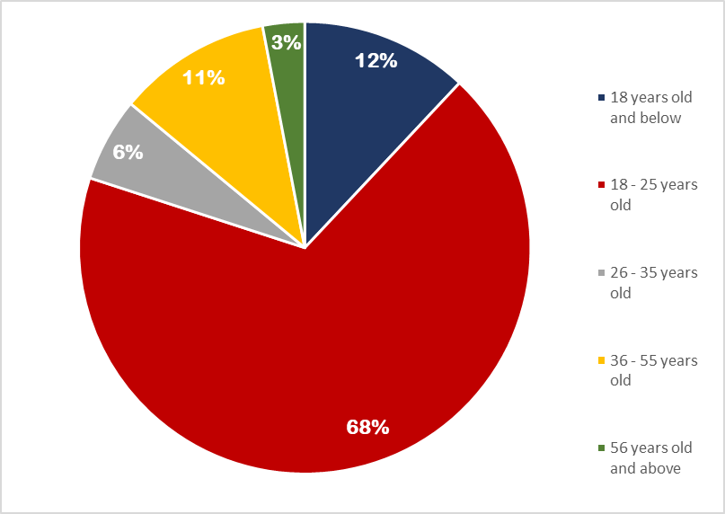

The consumer behaviour analysis of Nestle markets in both Nigeria and Malaysia shows the company's flexibility in adapting to diverse cultural and market dynamics. Nestle's longstanding presence in Nigeria, which is marked by its high-quality nutritious products, goes along with its commitment to improving the quality of life and contributing to a healthier future. The research on advertising impact in Nigeria reveals that continuous advertising plays a pivotal role in shaping consumer perceptions and driving purchasing decisions. Similarly, Nestlé's strategic adaptation in the Nigerian market, as evidenced by the study on the chocolate beverage market, reflects the company's dedication to creating shared value by aligning its products with local preferences. The study on customer happiness and brand loyalty in Malaysia shows a good relationship, with Nestlé's products developing significant brand trust and loyalty, particularly among the youth demographic.

**4.0 COMPETITOR ANALYSIS: NIGERIA AND MALAYSIA**

Nestle faces formidable competitors in the food industry in Nigeria. Companies like BUA Foods Plc boast impressive 80.95% net sales revenue growth in Q3 2022, indicating a strong market presence in cane sugar manufacturing and sugarcane farming. However, the company grapples with a concerning debt-to-equity ratio of -19.92%, signifying potential financial challenges (Bhasin, 2023). Cadbury Nigeria Plc exhibits commendable 39.17% growth, emphasising its significance in sugar and confectionery product manufacturing. Notably, its exceptionally high debt-to-equity ratio of 1623.45% raises financial leverage concerns (Heartofcodes, 2023). In contrast, McNichols Consolidated Plc showcases steady growth and a moderate debt-to-equity ratio, implying financial stability in chocolate and confectionery manufacturing.

In Malaysia, nestle competes with global giants like Lindt & Sprungli, which leads with 7.5% net sales revenue growth and an 18.5% operating profit margin. Nestle shows a competitive edge with 5% growth and a 15% operating profit margin. Both Lindt & Sprungli and Hershey (Nestle-Owler Competitors, 2022). Malaysia exhibits lower debt-to-equity ratios, which indicates a more conservative financial system. This analysis shows Nestle's robust position in the realm of diverse competitors, with a strong performance in key financial metrics, making sure its long-term relevance and success in the Malaysian market (Nestle-Global data, 2022).

**Figure 4.1:** Net Sales Revenue Growth Comparison of Nestle Nigeria Competitors

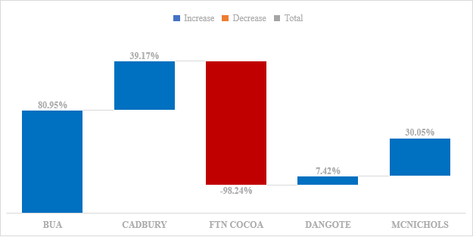

**Table 4.1:** Financial Performance Snapshot of Selected Nigerian Food Companies (Q3 2022 - Q3 2023)

|  |  |  |  |  |  |
| --- | --- | --- | --- | --- | --- |
| **Company** | **Net Sales Revenue Growth (%)** | **Operating Profit Margin (%)** | **Return on Equity (ROE)** | **Debt to Equity Ratio** | **Key Activities** |
| BUA FOODS PLC | 80.95% (2022Q3C) | 2.34% (2022Q3C) | 8.02% (2022Q3C) | -19.92% (2022Q3C) | Cane Sugar Manufacturing, Sugarcane Farming |
| CADBURY NIGERIA PLC | 39.17% (2022Q3C) | 8.52% (2022Q3C) | N/A | 1623.45% (2022Q3C) | Sugar and Confectionery Manufacturing, Chocolate Manufacturing |
| FTN COCOA PROCESSORS PLC | -98.24% (2023Q3C) | 2.14% (2023Q3C) | N/A | 77.09% (2023Q3C) | Chocolate and Confectionery Manufacturing from Cacao Beans |
| DANGOTE SUGAR REFINERIES PLC | 7.42% (2023Q3C) | 2.14% (2023Q3C) | N/A | -0.12% (2023Q3C) | Sugar Manufacturing |
| MCNICHOLS CONSODILATED PLC | 30.05% (2023Q2C) | 0.33% (2023Q2C) | 1.62% (2023Q2C) | -12.06% (2023Q2C) | Chocolate and Confectionery Manufacturing, Dairy Product Manufacturing |

**Table 4.2**: Nestle’s Competitor Overview and Key Details

|  |  |  |  |  |
| --- | --- | --- | --- | --- |
| **Company** | **Headquarters** | **No. of Employees** | **Revenue** | **Entity Type** |
| Chocoladefabriken Lindt & Sprungli AG | Switzerland | 14,160 | $5.2B | Public |
| PT Mayora Indah Tbk | Indonesia | [Data not available] | [Data not available] | Public |
| Yeo Hiap Seng Ltd | Singapore | 1,781 | $259.8M | Public |
| Hershey Malaysia Sdn. Bhd. | Malaysia | [Data not available] | [Data not available] | Private |

In the study of significant differences among the key competitors, Chocoladefabriken Lindt & Sprungli emerges as a frontrunner, flaunting very high net sales revenue growth, which indicates a robust market performance. Additionally, its leading operating profit margin suggests efficient operational management. Nestle and Yeo Hiap Seng Ltd. also show positive growth in net sales revenue, positioning them as strong competitors in the market. Nestle continues to maintain competitive profit margins while remaining a strong competitor, while Mayora Indah Tbk exhibits a commendable performance. Interestingly, Lindt & Sprungli and Hershey Malaysia Sdn. Bhd. showcase lower debt-to-equity ratios, implying prudent financial leverage. Nestle and Yeo Hiap Seng Ltd. continue to maintain a moderate ratio, striking a balance between financial stability and growth. Despite Lindt & Sprungli's significant performance, nestle still continues to remain a formidable competitor, and Mayora Indah Tbk, along with Hershey Malaysia Sdn. Bhd., have opportunities for improvement, particularly in optimising debt management.

**5.0 ENTRY STRATEGY EVALUATION**

**5.1 Nestlé's Entry Strategy in Nigeria**

**5.1.1 Historical Evaluation:**

Nestle's entry into Nigeria in 1961 can be said to be a strategic capitalization on the country's post-independence era, aligning with an exponential increase in population growth and a growing demand for processed food. The early presence of imports laid the groundwork for the official entry, and a diverse market was navigated by Nestle through localization, distribution networks, targeted marketing, and substantial investments in local production. The company's commitment to local varieties and production instilled brand loyalty and played an important role in its market dominance (About Nestlé in Nigeria | Nestlé, n.d.).

**5.1.2 Critical Evaluation**

Nestle's entry strategy in Nigeria has been studied to be strategically sound, with a dominant market share and significant contributions to the local economy. The localization approach and investment in local production created a deep connection with consumers and fostered job creation. Challenges such as intensifying competition and economic fluctuations are inevitable but require continuous adaptation (Bishopton, 2018). The commitment to creating shared value and understanding local dynamics positions Nestle for sustained success in this dynamic market.

**5.2 Nestle’s Entry Strategy in Malaysia**

**5.2.1 Historical Evaluation**

The emergence of Nestle in the Malaysian market began in 1912 with the establishment of the Anglo-Swiss Condensed Milk Company in Penang. The pivotal moment came in 1962, when its first factory in Petaling Jaya was established. Nestle's success in Malaysia can be seen as a result of early entry, localization of products, a robust distribution network, effective marketing, and strong relationships. The company's strategy involves partnerships through diversification and acquisitions, which leads to its market dominance and brand recognition (Mui Hung Kee et al., 2023)

**5.2.2 Critical Evaluation**

Nestle's entry into Malaysia has been a resounding success, thanks to the company's ability to adapt to local preferences, foster strong relationships, and effectively navigate challenges. Early entry and a focus on localization, coupled with strategic marketing and partnerships, have propelled Nestle to market leadership. Changing consumer preferences and intense competition are some of the challenges that require ongoing adaptation and innovation. The overwhelming presence of Nestle in the market and commitment to local collaborations position the company for sustained success in the Malaysian market (Huang, 2023).

**Table 5.1**: Evaluation Summary Table

|  |  |  |
| --- | --- | --- |
| **Aspect** | **Nestle in Nigeria** | **Nestle in Malaysia** |
| Historical Timeline | 1961: Official entry following early imports | 1912: Anglo-Swiss Condensed Milk Company established |
|  |  | 1962: Inauguration of the first factory in Petaling Jaya |
| Success Factors | Localization, Distribution Network, Marketing, Local Production | Early Entry, Product Localization, Distribution, Marketing, Partnerships |
| Challenges | Intensifying Competition, Economic Fluctuations, Shifting Consumer Preferences | Intense Competition, Economic Fluctuations, Changing Consumer Preferences |
| Evaluation | Dominant market share, Economic and Social Impact | Market leadership, Agility in adapting to challenges |

**6.0 SEGMENTATION, TARGETING AND POSITIONING ANALYSIS**

**6.1 Nestlé's Segmentation, Targeting, and Positioning in Nigeria**

Nestle's STP strategies in the Nigerian market are a factor in the diverse consumer landscape, which contributes significantly to its dominance in the market. The company’s segmentation approach is multifaceted, considering demographics like age and income, along with psychographics like lifestyle and values. This helps Nestle tailor products like Milo for children's consumption, Maggi for household use, and Nescafe for professionals. The targeting strategy focuses basically on middle-income families with young children, a wise choice given their substantial and progressive market presence. Nestle's positioning in Nigeria is a well-defined and sensitive one; it focuses on family nutrition, convenience in households, quality of products, and innovation across various product lines.

However, despite the success, some challenges still persist. There has been an increase in competition, which calls for unique and continuous creativity, and consumer choices, which are dynamic, also necessitate adaptive strategies. Economic instability also poses a risk; this requires Nestle to stay conscious of their approaches to pricing and promotions. Nonetheless, it is apparent from the STP analysis that Nestle's has been able to navigate complexities and maintain a strong market position in Nigeria.

|  |  |
| --- | --- |
| **Aspect** | **Details** |
| Segmentation | - Demographics: Age, income.  - Psychographics: Lifestyle, values.  - Geographic: Urban and rural areas. |
| Targeting | - Primary focus on middle-income families with young children.  - Niche targeting of professionals and health-conscious individuals. |
| Positioning | - Emphasis on family nutrition, convenience, quality, and innovation.  - Specific products positioned for different consumer needs. |
| Successes | - Market dominance in Nigeria.  - Tailored products for diverse consumer segments. |
| Challenges | - Rising competition demanding continuous innovation.  - Changing consumer preferences requiring adaptability. |

**6.2 Nestlé's Segmentation, Targeting, and Positioning in Malaysia**

Nestle's segmentation, targeting, and positioning (STP) strategies in the Malaysian market are an effective approach that caters to diverse consumer needs. In terms of segmentation, Nestle adopts a multi-layered system; they consider major demographic factors, which include age, income, and ethnicity; psychographic elements like lifestyle and values; and behavioural aspects like purchase habits and brand loyalty. For example, Milo targets kids, Maggi addresses household cooking individuals, and Nestle Purelife appeals to health-conscious consumers. This segmentation approach enables Nestle to offer a wide range of products tailored to specific consumer preferences.

Nestle adopts a strategy of targeting that is quite unique, focusing on specific segments with customised offerings and marketing campaigns. The company targets children with Milo's sports-oriented messaging or caters to spicy food enthusiasts with Maggi Pedas Cili Api. Nestle also ensures that each product has a distinct identity within its target segment. This targeted approach allows Nestle to connect with consumers on a more personal level, fostering brand loyalty and resonating with the diverse Malaysian market. Finally, Nestle's positioning is strategic; it presents unique benefits and value propositions for each of their brands. Milo is positioned for energy and growth, Maggi for cooking and taste, and Nestle Purelife for health and wellness. This deliberate positioning strengthens the brand's image and contributes to Nestle's market leadership in Malaysia.

|  |  |
| --- | --- |
| **Aspect** | **Description** |
| Segmentation | - Demographic: Age, income, family size, ethnicity - Psychographic: Lifestyle, attitudes, values - Behavioural: Usage occasion, purchase habits, brand loyalty |
| Targeting | - Differentiated strategy - Examples: Milo for active kids, Nestle Professional for food service, Maggi Pedas Cili Api for spicy food enthusiasts |
| Positioning | - Strategic positioning for each brand - Milo for energy and growth, Maggi for convenience and taste, Nestle Purelife for health and wellness |

During the comparison of Nestlé’s Segmentation, Targeting, and Positioning (STP) strategies in Nigeria and Malaysia, some common trends and differences emerge. Both countries have Nestlé's adept use of multifaceted segmentation, incorporating demographic and behavioural factors to tailor products to diverse consumer needs. However, the demographic system differs; for Nestlé in Nigeria, targeting middle-income families with young children is the employed approach, while in Malaysia, a much wider approach that considers factors like age, income, and ethnicity is considered. The targeting strategy in Malaysia is more diversified; the system caters to specific segments like active kids and spicy food enthusiasts. Despite these variances, Nestlé's positioning continues to be consistent in maximising unique benefits and value propositions for each brand in both countries, contributing to its market leadership. The comparative analysis helps to highlight Nestlé's flexibility in adapting its STP strategies to specific consumer landscapes while maintaining a strong brand presence across diverse markets.

**7.0 MARKETING STRATEGIES (4 P’S) EVALUATION**

**7.1 Product Strategy**

A deep understanding of local preferences, backed by a commitment to innovation and adaptation, is observed in Nestle product strategy in both Nigeria and Malaysia. In Nigeria, Nestle focuses on a wide range of products, including dairy, chocolates, beverages, and ready-to-cook foods. The efforts due to localization are evident in products like Maggi, adapted to Nigerian flavours (Nestlé Marketing Mix (4Ps) Analysis n.d.). Similarly, in Malaysia, Nestle directs its products to suit local tastes and demands, introducing products like Indomie noodles and Nunu milk drinks. In the company's continuous innovation, they introduce Maggi Pasta and Maggi Sauce, showcasing its responsiveness to changes in consumer preferences. Despite facing strong competition, Nestle's strategy of combining localised products with global brands contributes to its success in both markets (Nestle India, n.d.).

|  |  |  |
| --- | --- | --- |
| **Aspect** | **Nigeria** | **Malaysia** |
| Dairy Products | Nestle milk, nestle slim, Nestle every day | Milo |
| Chocolates | KitKat, Munch, Éclairs, Polo, Milky Bar | Kit Kat, Nestle Alpino, Limited-edition flavors |
| Beverages | Nescafe | Milo Active, Nescafe 3in1 |
| Ready-to-Cook | Maggi Instant Noodles, Maggi Pasta, Maggi sauce | Maggi 2-Minute Noodles |

**7.2 Pricing Strategy**

Nestle adopts a strategic pricing approach in both Nigeria and Malaysia, considering some factors similar tin the two countries which include; product quality, competitor pricing, and regional dynamics. In Nigeria, products like Maggi are priced higher than some competitors, emphasizing the perceived value and quality. The company uses various SKU sizes and bulk discounts to cater for the diverse consumer budgets (Nestle, 2024). Similarly, in Malaysia, nestle competes with local and international players by offering competitive prices. The involves launching products at different price points to reach a broad customer base. The pricing is influenced by factors such as product quality, competitor pricing, and regional variations (Sanchez, 2016).

|  |  |  |
| --- | --- | --- |
| **Aspect** | **Nigeria** | **Malaysia** |
| Pricing Strategy | Perceived quality-based pricing | Competitive pricing strategy |
| SKU Variation | Various sizes and bulk discounts | Multiple price points for SKUs |

**7.3 Place and Distribution Strategy**

Nestle's distribution strategy plays a crucial role in ensuring the availability and accessibility of its products in both Nigeria and Malaysia. In Nigeria, the majority of sales come from European countries, and Nestle follows a fast-moving consumer goods (FMCG) distribution channel (Team, 2021). This involves products moving from factories to distributors, then to retailers, and finally reaching consumers. In Malaysia, Nestle maintains a strong distribution network, collaborating with local partners and utilising warehouses for efficient product movement. The challenges in distributing chocolates are acknowledged, emphasising the importance of strong partnerships to overcome market competition (Uwakmfon, 2019).

|  |  |  |
| --- | --- | --- |
| **Aspect** | **Nigeria** | **Malaysia** |
| Sales Contribution | Majority from European countries | Diverse geography in Malaysia |
| Distribution Channel | FMCG distribution channel | Strong network with local partnerships |
| Challenges | Distribution of chocolates is a challenge | Intense competition in the market |

**7.4 Promotional and Advertising Strategy**

Nestle's promotional and advertising strategies in Nigeria and Malaysia are dynamic, leveraging a mix of traditional and digital channels while emphasising brand strength and local relevance. In Nigeria, Nestle has employed unique marketing ideas, associating Maggi with quick snacks through campaigns targeting mothers and children (Nestle-Owler Competitors Online). The company's strong presence at ground level, particularly with Maggi and Nescafe, contributes to effective sales and promotions. In Malaysia, Nestle's advertising mix includes TV, radio, social media, and influencer partnerships. Campaigns like "Nestle Cares" showcase the brand's commitment to community engagement. Nestle's ability to create culturally relevant campaigns and engage with consumers through various channels contributes to its success in both markets (our leadership team, n.d.).

|  |  |  |
| --- | --- | --- |
| **Aspect** | **Nigeria** | **Malaysia** |
| Marketing Ideas | Maggi associated with quick snacks | "Nestle Cares" community engagement |
| Media Mix | TV, hoardings, print, online ads | TV, radio, social media, influencer partnerships |
| Brand Association | Strong presence of Maggi and Nescafe | Leveraging global brand recognition |

**CONCLUSION**

Nestlé's success in Nigeria and Malaysia is rooted in its navigation of diverse markets through strategic entry, comprehensive STP strategies, and tailored marketing approaches. The company's willingness to foster localization, innovation, and understanding of local preferences has fortified its market leadership. Despite challenges, Nestlé's product adaptation, pricing strategies, robust distribution networks, and impactful advertising contribute to sustained growth in these dynamic markets, reflecting its resilience and agility in the ever-evolving food and beverage industry.

**REFERENCES**

About Nestlé in Nigeria | Nestlé (n.d.) Nestlé. [Online] https://www.nestlecwa.com/en/csv/nestl%C3%A9-nigeria/about-nestl%C3%A9-nigeria.

Alexander, E., Yach, D., & Mensah, G. A. (2011) “Major multinational food and beverage companies and informal sector contributions to global food consumption: implications for nutrition policy.” Globalization and Health. Springer Science and Business Media LLC, 7(1).

Berry, L. L., Zeithaml, V. A., & Parasuraman, A. (1983). Quality counts in services, too.

Brexit’s impact on the resilience of local food supply chains: potential opportunities and threats (2019) Continuity & Resilience Review. Emerald, 1(2) pp. 92–94.

Bishopton, M. I. (2018). Adaptation of Marketing Strategy of Multinational Companies on Foreign Local Market: Based on Nestlé Chocolate Beverage Market in Nigeria. Bachelor's thesis, Tallinn University of Technology, School of Business and Governance, Department of Business Administration. Supervisor: Sirje Ustav, MA

Business Horizons, 28(3), 44-52. [Online] Available at: https://www.sciencedirect.com/science/article/abs/pii/0007681385900084

Bhasin, H. (2023) Top Nestle Competitors (Updated in 2023). Marketing91. [Online] https://www.marketing91.com/top-nestle-competitors-across-the-world/.

Ching, E. (2022) Fulfilling consumer needs, but at what cost? A case study on the framing of Nestlé. [Online] https://theses.ubn.ru.nl/items/bb0bc133-63b6-460c-af50-604e98aeffe6.

Cuofano, W. I. G. (2023) Nestlé Competitors. FourWeekMBA. [Online] https://fourweekmba.com/nestle-competitors/.

DEMİR, Y., and ISTANBULLU DİNCER, F. (2020) “The Effects of Industry 4.0 on the Food and Beverage Industry.” Journal of Tourismology. Istanbul University, August, pp. 133–145.

Heartofcodes (2023) Competitors of Nestle | Top Nestle Competitors - 2023. Heart Of Codes. [Online] <https://heartofcodes.com/competitors-of-nestle/>.

Huang, Z. (2023) “Human rights responsibilities of Nestle Swiss multinational food and beverage company.” Highlights in Business, Economics and Management. Darcy & Roy Press Co. Ltd., 7, April, pp. 257–262.

LAYMAN, P. L. (1989) “Finland’s Neste Increasing Stake in West European Chemicals Market.” Chemical & Engineering News Archive. American Chemical Society (ACS).

Marin, D., and Verdier, T. (2007) “Power in the Multinational Corporation in Industry Equilibrium.” SSRN Electronic Journal. Elsevier BV.

Mui Hung Kee, D., Gan, Z. W., Chan, Y. Q., Lee, H. T., Tan, X. Y., & Lee, S. W. (2023). Customer Satisfaction and Brand Loyalty: A Case Study of Nestlé. Universiti Sains Malaysia, Jalan Sg Dua, 11800 Minden, Pulau Pinang, Malaysia. Correspondence Email: daisy@usm.my. ORCID ID: 0000-0002-7748-8230

Nestle Competitors and Alternatives (2022) Owler Competitors. [Online] https://www.owler.com/company/nestle/competitors/.

Nestle India Ltd Share Price Today - Nestle India Ltd Share Price LIVE on NSE/BSE (n.d.). [Online] https://www.tickertape.in/stocks/nestle-india-NEST.

Nestlé Marketing Mix (4Ps) Analysis (n.d.) Edrawsoft. [Online] https://www.edrawmind.com/article/nestle-marketing-mix-analysis.html.67(9) pp. 13–15.

Nestlé Market segmentation, targeting, and positioning (n.d.) Edrawmind. [Online] https://www.edrawmind.com/article/nestle-segmentation-targeting-and-positioning.html.

Nestlé’s Expansion into China | Analysis (2023). [Online] https://www.ukessays.com/essays/management/nestle-company-in-china-management-essay.php.Emerald, November.

Nestle SA Peers & Key Competitors - GlobalData (2022). [Online] https://www.globaldata.com/company-profile/nestle-sa/competitors/.

Our leadership team (n.d.) Nestlé Global. [Online] https://www.nestle.com/about/management.

Post, J. E. (1985) “Assessing the Nestlé Boycott: Corporate Accountability and Human Rights.” California Management Review. SAGE Publications, 27(2) pp. 113–131.

Sánchez, A. G., Molero, J., and Rama, R. (2016) “Local cooperation for innovation: food and beverage multinationals in a peripheral European country.” International Journal of Multinational Corporation Strategy. Inderscience Publishers, 1(2) p. 107.

Team, M. S. (2021) Nestle Marketing Strategy & Marketing Mix (4Ps). MBA Skool. [Online] https://www.mbaskool.com/marketing-mix/products/16825-nestle.html.

Topic: Nestlé (2024) Statistahttps://www.statista.com/topics/1439/nestle/#topicOverview.

Uwakmfon (2019) *THE EFFECT OF ADVERTISING ON CONSUMER BUYING BEHAVIOUR (A CASE STUDY OF NESTLE FOOD NIGERIA PLC)*. Modish Project. [Online] https://www.modishproject.com/the-effect-of-advertising-on-consumer-buying-behaviour-a-case-study-of-nestle-food-nigeria-plc/.

Wolf, M. E., Emberger-Klein, A., and Menrad, K. (2023) “From consumer values to attributes of natural health products for concentration and cognition: insights from a means-end-chain study.” International Journal of Pharmaceutical and Healthcare Marketing.